Overview
This document looks at Ofsted’s current guidance as set down in the 2019 framework and explained in the latest School Inspection Handbook.
It shows how well-planned local history and heritage activities can help schools to demonstrate what Ofsted looks for in relation to the effectiveness of schools. In particular, the quality of education that pupils experience and their personal development, behaviour and attitudes.

The School Inspection Handbook, for use from September 2019 (Reference No.190017)
The inspection framework has changed markedly, and this diagram provides a useful summary of the four key sections and their sub sections.


Quality  of  education | Intent  - Curriculum design, coverage and appropriateness | Behaviour and attitudes      Leadership and management  Personal development | - Attitudes to learning  - Behaviour  - Employability  - Attendance and punctuality  - Respect
Quality  of  education | Implementation  - Curriculum delivery  - Teaching (pedagogy)  - Assessment (formative and summative) |  | - Enrichment  - FBV  - Careers guidance  - Health and well-being  - Citizenship  - Equality and diversity  - Preparation for next steps
Quality  of  education | Impact  - Attainment (qualifications and assessments)  - Progress  - Knowledge and skill development  - Destinations |  | - Vision and ethos  - Staff development  - Staff workload and well-being  - Student experience  - Governance/oversight  - Safeguarding

Since September 2019, the curriculum has been put back at the heart of school inspections.

Safeguarding rightly remains a core element of every inspection, as does an evaluation of the effectiveness of leadership and management.
The judgement for personal development recognises the work schools and colleges do to build young people’s resilience and confidence in later life, and a new separate behaviour and attitudes judgement assesses how well schools are creating a calm, well-managed environment free from bullying.

- Quality of Education and the Curriculum
The revised framework focuses inspection on:
- what a school is trying to achieve through its curriculum (intent)
- how it is being delivered (implementation)
- the difference it is making to pupils’ learning (impact)
Through ‘deep dives’ into individual subjects, inspectors will explore what is taught, when and why it is taught. They will subsequently investigate whether these intents are being met and the impact all this is having as part of the quality of education that pupils receive. Inspectors will specifically explore ‘whether leaders are following the national curriculum and basic curriculum or, in academies, a curriculum of similar breadth and ambition’ (Handbook para 179)
The curriculum, (including the requirements of the National Curriculum) has always mattered but this is now recognised through inspection practice.


Use of local heritage in the curriculum can significantly add to your school’s Quality of Education.

Curriculum Intent
- Your curriculum intent includes everything that happens before teaching takes place. As a result, planning and sequencing matter
- The National Curriculum acts as your framework for intent. You have the flexibility to design your own school curriculum within this framework
- There is no such thing as an 'Ofsted-approved' curriculum because this will depend on your school's context. Your school context matters. Handbook para 172: The curriculum reflects the school’s local context by addressing typical gaps in pupils’ knowledge and skills
- what you do will be different because of your school community, your pupils and your location


Remember
Your school context includes your school’s unique locality and its heritage.
- your local, natural and built environment and its heritage, contribute to who your children are and therefore will influence how and what you want them to learn in order to ‘prepare them for the opportunities, responsibilities and experiences of adult life’
- use it when designing your curriculum in order to create a local curriculum relevant to your pupils

When planning to use local heritage:
- use the Local Heritage Research Guide: First Steps – EYFS to KS2 to help you find out what is worth knowing in your area
- identify what you want your pupils to know by the time they leave your school
- use it to enhance the teaching of history and geography :
  - to develop a coherent progression model for invaluable knowledge & skills
  - to make links to regional, national and global themes
- use it to create links within and across whole school activities and all subjects

The Broad and Balanced Curriculum for All
Ofsted Focus: cultural capital and whether schools are ‘equipping pupils [especially those who are disadvantaged and have SEND] with the knowledge and cultural capital they need to succeed in life’. (handbook para 178)
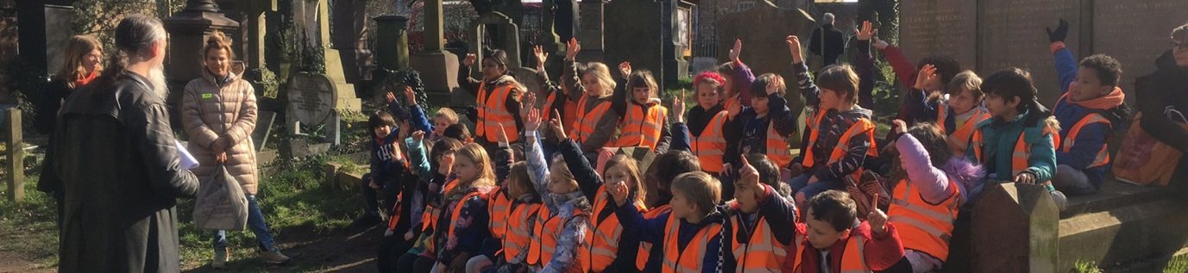
Cultural capital is defined as ‘the essential knowledge that pupils need to be educated citizens, introducing them to the best that has been thought and said and helping to engender an appreciation of human creativity and achievement’. (Handbook para 178)

Remember
Your local history and heritage studies provide many opportunities for curriculum breadth:
- it engenders an appreciation of human creativity and achievement in the locality
- includes the heritage and histories of diverse communities
- heritage supports learning within, across and between subjects and activities
- it develops knowledge and skills, not just in history and geography, but also numeracy, science, literacy, art and design and SMSC
- talking about places children know is an easy way to engage learning and therefore, supports all pupils of all abilities to access an ambitious curriculum
- local is often the best first step to pupils grasping subjects themes and events on a national and global scale

Local history and heritage studies provide many opportunities for curriculum depth because they can be easily revisited throughout the spiral curriculum and specific topics can be focused upon and explored with incremental knowledge and skills.

Building a connected and coherent curriculum
When considering and summarising your curriculum purpose you should plan how this ambition runs through and connects your curriculum in all subjects and in all that you do.

Remember
- your local context can act as the ‘golden thread’ that binds your curriculum together
- use it to connect the learning!



Curriculum Implementation and Impact
- Curriculum Implementation is all about the teaching and assessment of your intent – in other words how the curriculum is delivered
- Curriculum impact refers to the difference the work you have planned has made to pupils’ knowledge and learning
When setting down the aims of what you want to achieve, bear in mind the following important definitions;
- Learning is defined as an alteration in long-term memory. If nothing has altered in long-term memory nothing has been learned
- Progress means knowing more, remembering more and being able to do more. As a result, knowledge matters – its acquisition, application, retention and retrieval

Your curriculum is the progression model.

Remember
Curriculum Implementation
Take advantage of the benefits of going local and consider that your unique heritage, including its natural and built environment can contribute positively to ‘how’ and ‘how well’ your children learn the curriculum because it:
  - hooks children into learning and makes it more meaningful
  - creates opportunities for learning outside the classroom and greater community links
  - supports ‘essential learning’ your pupils need in order to make progress in the curriculum
  - can be more readily revisited helping create a spiral curriculum where key concepts are connected and repeated, therefore going into long term memory with deepening levels of complexity
  - helps structure the ‘way points’ and ‘end points’ you need to create in order to assess this essential learning before moving forward
Curriculum Impact
Remember local heritage is essentially more memorable – so it sticks!

- Behaviour and Attitudes
The behaviour and attitudes judgement focuses upon ‘how leaders and staff create a safe, calm, orderly and positive environment in the school and the impact this has on the behaviour and attitudes of pupils’. (Handbook para 201)

An important aspect in all this is ‘pupils’ motivation and positive attitudes to learning as important predictors of attainment. The development of positive attitudes can also have a longer-term impact on how pupils approach learning tasks in later stages of education’. (Handbook para 202)

Remember
Research studies have shown that focusing on local studies helps to:

- motivate pupils and develop positive attitudes to learning
- improve commitment by creating greater relevance to the pupils own world
- improve self-esteem and pride in their achievements


(e.g. Heritage Schools Year One baseline research report 2016).

- Personal Development
The personal development judgement focuses upon evaluating ‘the school’s intent to provide for the personal development of all pupils, and the quality with which the school implements this work’. (Handbook para 216 )

Personal development also includes evaluating ‘the effectiveness of the school’s provision for pupils’ spiritual, moral, social and cultural education’. (Handbook para 219)

Remember
Using your locality and its heritage in the school curriculum can boost opportunities for pupils to strengthen their personal development and their spiritual, moral, social and cultural (SMSC) development and prepare them for life in modern Britain.
It can do this by helping learners to:
- develop their self-confidence and identity through an understanding of ‘Place’
- be responsible, respectful and active citizens developing resilience and independence by learning about the community and places in which they live
- contribute positively to society by becoming actively involved in local community projects which contribute to the lives of those living and working in their locality
- go beyond the curriculum, supporting their broader development, enabling learners to develop and discover their interests and talents outside the classroom and to help them know how to keep physically and mentally healthy
- develop their understanding of fundamental British values such as learning about buildings which provide public services acquiring a broad general knowledge of, and respect for, public institutions
- develop their understanding and appreciation of diversity by learning about the story of places that matter to people of different age groups, ethnicity, culture and faith
- celebrate what we have in common

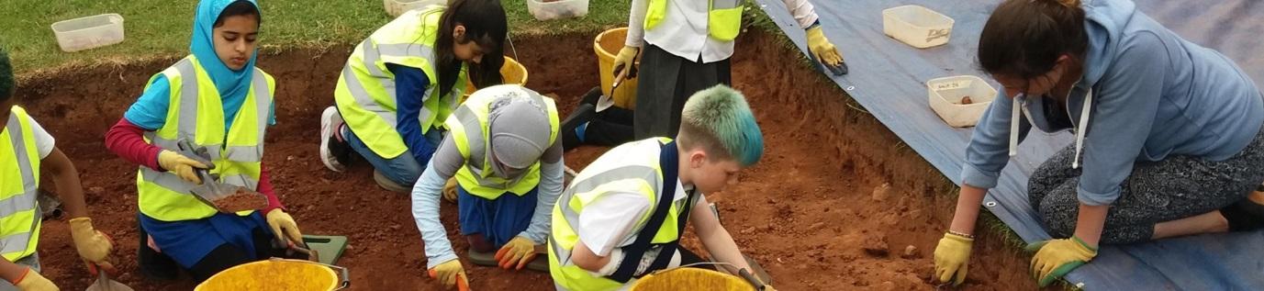

- Leadership and Management
The leadership and management judgement focuses upon ‘how leaders, managers and those responsible for governance ensure that the education that the school provides has a positive impact on all its pupils’. (Handbook para 229)

In listing the important factors for inspectors to consider, the inspection handbook includes the following:

- whether continuing professional development for teachers and staff is aligned with the curriculum, and the extent to which this develops teachers’ content knowledge and teaching content knowledge over time, so that they are able to deliver better teaching for pupils (Handbook para 229)

You must ensure that any CPD undertaken links directly to the curriculum.

Remember
Effective Local Heritage CPD will enable schools to be better placed to support the use of locality within and across the curriculum by helping teachers to:
- know more about the locality in which they teach
- know how to research and where to find support, resources and partnerships with local heritage providers
- understand how they can use their locality and heritage as one aspect of ‘local context’ for curriculum planning
- become more confident in why, when and how to use local heritage to support the school’s broad and balanced curriculum
- know how heritage can be linked to what else is being studied at that time in each year group and how it links to what has been studied before and will be studied later
- provide high-quality, inclusive education and training to all

Use of shared local heritage and knowledge can support leaders to engage effectively with their community to:
- become more involved in school life
- create opportunities for inter-generational learning

Remember
- schools that pursue local history and heritage enquiries are potentially well placed to meet the requirements of the current inspection framework
- most important of all is the idea that local history and heritage link seamlessly to the curriculum and can underpin everything that is studied – remember the golden thread
- never forget the contribution this work can make to pupil’s behaviour and attitudes and their personal development
- make those positive links to leadership and management

