Schools can enhance pupils’ spiritual, moral, social and cultural development by enabling them to:
- Investigate the function and history of civic buildings and sites of cultural significance
- Research local significant people and their impact on the community and wider world
- Identify changing social, cultural and ethnic influences on local design and architecture
- Examine our rights and responsibilities towards the built environment
- Explore local places of worship and memorials and consider how they have changed to reflect their community
Suggested activities:
- Run a campaign to protect ‘Heritage at Risk’, Conservation Areas and/or repurpose a disused site e.g. a former chapel.
- Photograph, sketch or make a model of your favourite listed site and upload it to ‘Enrich the List’.
- Debate changes to the local built environment or ‘contested history’.
- Design a poster to advertise your village/town/area to visitors for display in a community space.
- Carry out a condition survey and ‘adopt’ your local war memorial and/or war graves.
- Map key civic buildings and places of worship and/or present a tour of a local building(s) e.g. an I-Spy of different architectural features.
- Write a speech to campaign for wider recognition of a significant local person e.g. faith leader, reformer, philanthropist.
- Develop a timeline incorporating local people and places and the impact of social, economic, political, cultural and religious developments on the local community.
- Interview local people about changes in the built environment and capture their stories about key community spaces and events.
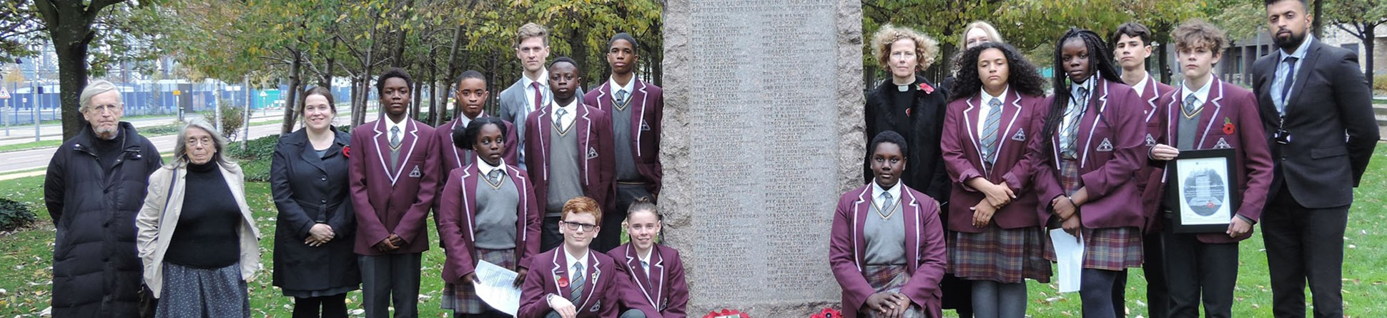
- Write a newspaper report or film a news item about local heritage crime.

