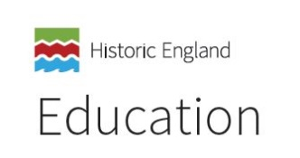
What pupils should know, understand and be able to do at the end of each key stage

By the end of the Early Years, pupils should be able to:
- understand the passage of time and how things change over time
- use the correct language, such as ‘yesterday’ and ‘past’, and look at the differences
- between ‘long ago’ and ‘now’
- ask questions about artefacts, suggesting what they might be used for
- make accurate comparisons between modern and old objects
- develop chronological understanding and an interest in history

By the end of Key Stage 1 pupils should be able to:
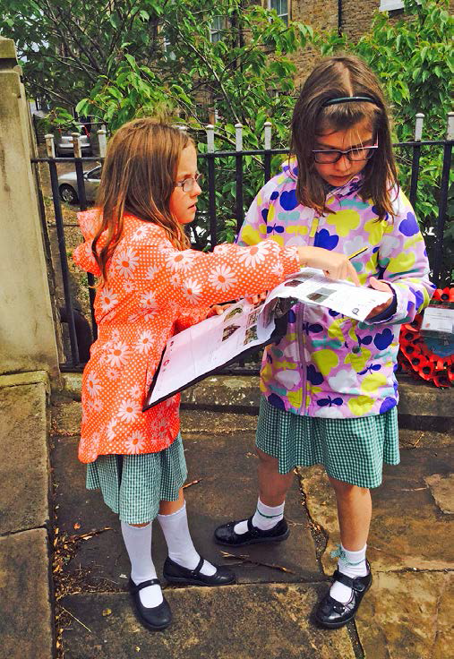 | - develop an awareness of the past and be able to reflect on the significance of what they learn  - know where all people/events studied fit into a chronological framework  - use common words and phrases relating to the passing of time and use a wide vocabulary of everyday historical terms  - recount stories accurately and suggest why people and events were important  - identify similarities/differences between periods  - understand some of the ways we find out about the past, and understand the importance of basing ideas on evidence  - identify different ways in which the past is represented  - choose and use parts of stories and other sources to show knowledge and understanding of key features of the people/events studied  - analyse artefacts, ask questions about them and consider how they might find out the answers  - develop the skills of hypothesising, questioning and investigating to study history

By the end of Key Stage 2 pupils should be able to:
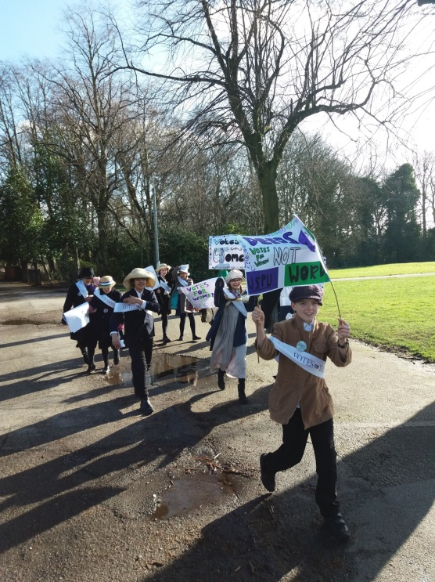 | - develop a chronologically secure knowledge and understanding of British, local and world history  - establish clear narratives within and across periods studied  - note connections, contrasts and trends over time  - develop the appropriate use of historical terms  - address regularly and sometimes devise historically valid questions about change, cause, similarity and difference, and significance  - construct informed responses by selecting and organising relevant historical information  - understand how our knowledge of the past is constructed from a range of sources  - identify anachronism, be aware of different views about the people/events studied and be able to give some reasons why different versions of the past exist  - evaluate a range of historical sources and make perceptive deductions about the reliability of sources in answering historical questions  - understand change and continuity, and the significance of people in a wider historical context  - use historical terms accurately, and make pertinent and valid comparisons between periods

By end of Key Stage 3 students should be able to:
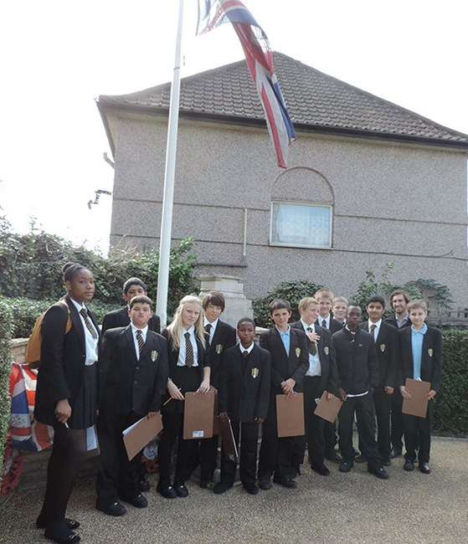 | - extend and deepen their chronologically secure knowledge and understanding of British, local and world history, so that it provides a well-informed context for wider learning  - identify significant events, make connections, draw contrasts, and analyse trends within periods and over long arcs of time  - use historical terms and concepts in increasingly sophisticated ways  - pursue historically valid enquiries including some they have framed themselves  - create relevant, structured and evidentially supported accounts  - understand how different types of historical sources are used rigorously to make historical claims  - understand significance and discern how and why contrasting arguments and interpretations of the past have been constructed  - appreciate clearly how to undertake an historical investigation, select relevant evidence, evaluate it and communicate their findings effectively

Within each key stage, teachers will have pupils who will exceed the expectations of what they should know, understand and be able to do by the end of that key stage. As a result, the expectations for pupils during the next key stage should always be considered.

